News for August 21, 2015
Officers for 2015 – 2016
President – Heather Taylor, Secondary Vice-President – Judy Tolley
Elementary Vice-President – Cindy Weaver
Secretary – Becky Tom, Treasurer – Martha Mitchell
Internal Communications Coordinator – Hillary McGee
External Communication Coordinator – Annette Porter
Technology Communications Coordinator – Steve Morrison

Building Representatives
Zanesville High School – Todd Riley, Elizabeth Wright, Emma Lucas
Zanesville Middle School – Missy Duffy, Michelle Neal
Zane Grey Elementary – Dee Peyton, Amanda Smock, Mike Lang, Angela WInegardner
National Road Elementary – Katie Sites, Melissa Morgan
John McIntire Elementary – Wendy Lowe, Shannon Barrett, Jenny Wahl

ZEA Schedule 2015 - 2016
ZEA Executive Committee - All 4:00 Monday August 31, 2015 at Pizza Cottage
Elementary Executive Committee 4:00 Wednesday September 30, 2015 at JME
Secondary Executive Committee 3:00 Thursday October 1, 2015 at ZHS
ZEA Executive Committee - All 4:00 Thursday October 29, 2015 at Pizza Cottage
Elementary Executive Committee 4:00 Wednesday November 18, 2015 at ZGE
Secondary Executive Committee 3:00 Thursday November 19, 2015 at ZMS
ZEA Executive Committee - All 4:00 Monday January 4, 2015 at Pizza Cottage
Elementary Executive Committee 4:00 Wednesday January 27, 2016 at NRE
Secondary Executive Committee 3:00 Thursday January 28, 2016 at ZHS
ZEA Executive Committee - All 4:00 Thursday February 25, 2016 at Pizza Cottage
Elementary Executive Committee 4:00 Wednesday March 23, 2016 at JME
Secondary Executive Committee 3:00 Thursday March 24, 2016 at ZMS
ZEA Executive Committee- All 4:00 Thursday April 28, 2016 at Pizza Cottage
ZEA Executive Committee- All 4:00 Thursday May 26, 2016 at Pizza Cottage

Check out our website information @ http://zanesvilleea.ohea.us/
Information found here includes: ZEA Officers, Delegates, Building Reps, Teaching Contract, Licensure Code of Professional Conduct, ZEA Scholarship, ZEA Media Release Form, ZEA Scholarship Information for our students, Newsletters, and ZEA Minutes.
All parts of the site are available to all members. Minutes are password protected per memberships request. Building reps will be contacting you in September to let you know your password.

We will be seeking OEA grant money this year to support us in our effort to build a better union. There are several grants that could provide thousands of dollars annually to ZEA. Throughout the year there are some things you can do to help us be successful in our grant request.
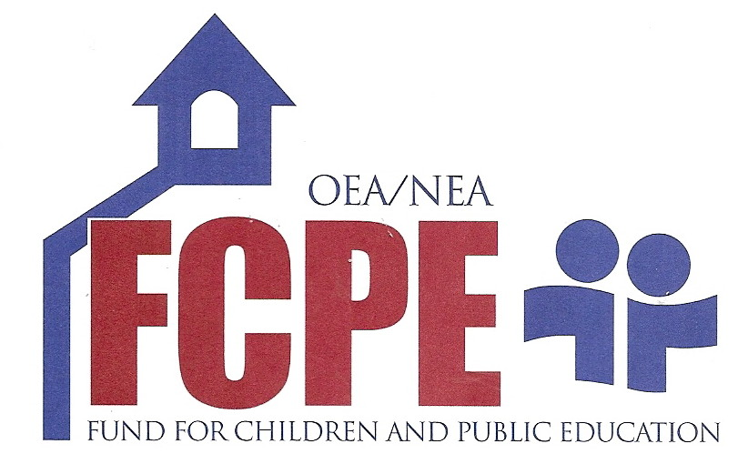
1. DONATE TO OUR FCPE DRIVE
WHAT IS FCPE? The OEA FCPE is our state Political Action Committee, which works to support pro-public education candidates on the ballot.
WHY POLITICS? All the decisions that affect us as public school employees, as well as individuals, are made by elected leaders or individuals appointed by elected leaders.
WHAT IS THE PROCESS? Screening Committees at local, district, and state levels are comprised of local leaders and representatives who are FCPE contributors. Candidates answer questions pertaining only to public education issues. Screening Committee members then make non-partisan recommendations and endorsements.
WHY GIVE? Decisions affecting future of public education are made in political bodies. FCPE allows for greater influence and united power and a greater pool of money. Provide monetary support to candidates who support public education. Dues dollars cannot be used to support candidates. Increased member participation will help us secure grants from OEA.
JUST $1.00 will help us, and if you give today, we will give you a candy bar.
2. LOOK FOR OUR MEMBER SURVEY INFORMATION AND GIVE US FEEDBACK ON WHAT YOU NEED ZEA TO DO FOR YOU.
Sometime this fall, after we have all had a chance to settle we will be contacting you with information about a survey. The grant money we seek will be tied to the needs identified in the survey. We want to provide the communication, professional development, and resources you need, so please let us know how the best serve you.

